VCS Task
Establish a new directory, populate it with script files, initiate an empty repository on GitHub, convert the local directory into a Git repository, and link it to GitHub for pushing the code into the repository.Perform merge, rebase, stash commands in following github repo.
1.Create directory & add script files, initialize Git locally:
O/P:
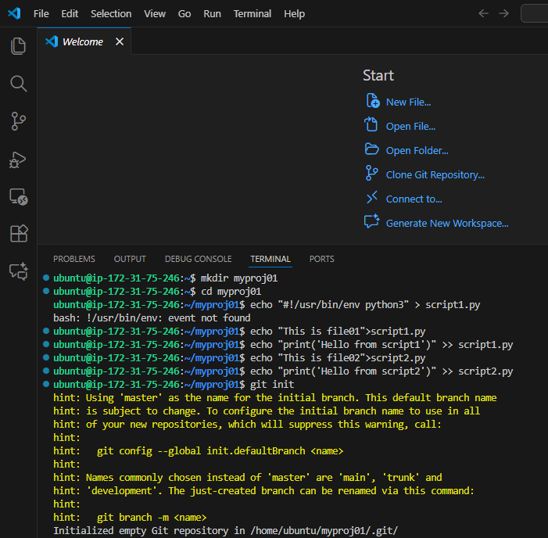
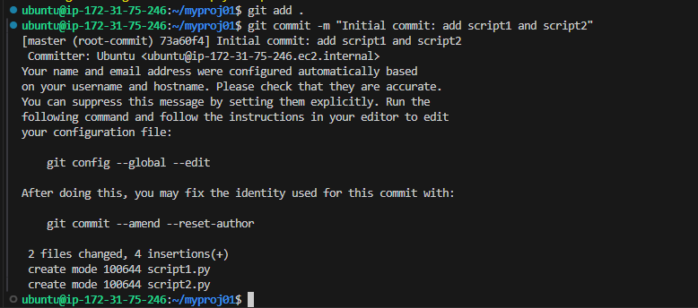

2.Create remote repository (on GitHub) and link remote
O/P:
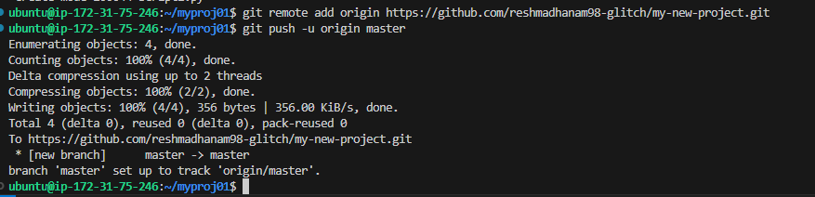
3.Demonstrate branching, merge, rebase, stash workflows
a) Create a new feature branch and commit changes
O/P:
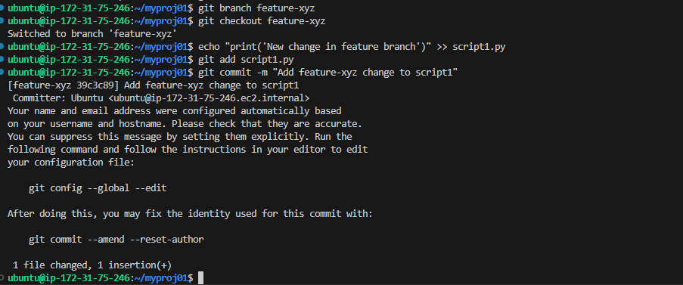
b) Merge:
O/P:
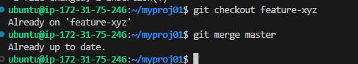
c)Rebase:
O/P:
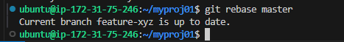
d)Stash:
O/P:

